**Extracting the Data with SQL**

In this Career Track Analysis with SQL and Tableau project, you’re tasked with analyzing the career track enrollments and completions of 365’s students. You’ll first need to retrieve the necessary information from an SQL database. Afterward, you’ll feed this information to Tableau and visualize the results.

Study the sql_and_tableau database, consisting of the following tables:

* career_track_info
  + track_id – the unique identification of a track, which serves as the primary key to the table
  + track_name – the name of the track
* career_track_student_enrollments
  + student_id – the unique identification of a student
  + track_id – the unique identification of a track. Together with the previous column, they make up the primary key to the table—i.e., each student can enroll in a specific track only once. But a student can enroll in more than one career track.
  + date_enrolled – the date the student enrolled in the track. A student can enroll in more than one career track.
  + date_completed – the date the student completed the track. If the track is not completed, the field is NULL.

Load the database from the sql_and_tableau.sql file. Using the career_track_info and career_track_student_enrollments tables in the database, select a dataset containing the following columns:

* student_track_id – this serves as an identification for each student-track pair. That is, each row of the resulting table should be uniquely labeled. Do this in an ordinal manner.  
  **Hint:***Research how the ROW_NUMBER function with the OVER clause work.*
* student_id – the unique identification of a student
* track_name – the name of the track
* date_enrolled – the date the student enrolled in the track
* track_completed
  + 0 – the track is not completed (the completion date is NULL)
  + 1 – the track is completed (the completion date is not NULL)
* days_for_completion – the difference in days between the completion date and the enrollment date  
  **Hint:***Research how the DATEDIFF function works.*
* completion_bucket – the bucket a student falls into based on the number of days it took them to complete a track (if they have done so). The buckets are as follows:
  + Same day – the days_for_completion field is equal to 0
  + 1 to 7 days – the days_for_completion field is between 1 and 7 days, inclusive
  + 8 to 30 days – the days_for_completion field is between 8 and 30 days, inclusive
  + 31 to 60 days – the days_for_completion field is between 31 and 60 days, inclusive
  + 61 to 90 days – the days_for_completion field is between 61 and 90 days, inclusive
  + 91 to 365 days – the days_for_completion field is between 91 and 365 days, inclusive
  + 366+ days – the days_for_completion field is more extensive than 365 days

Export the obtained result as a CSV file called career_track_completions.csv.

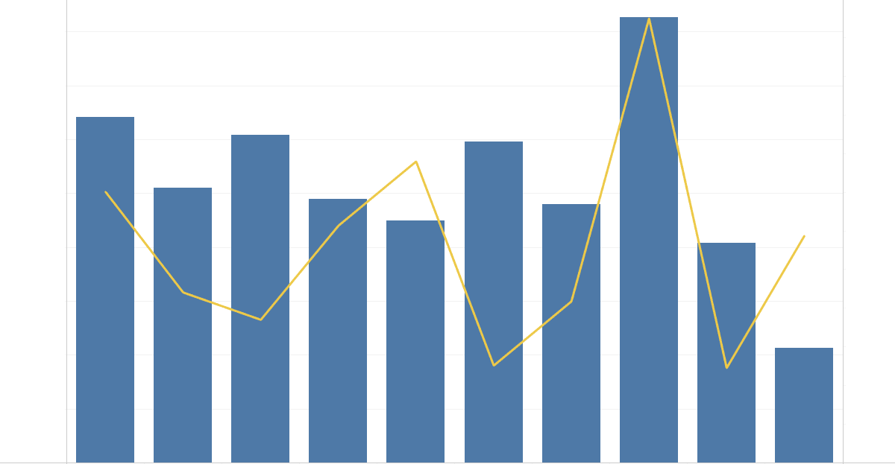

## nterpreting the Results

Congratulations on completing the practical part of the project! Now, analyzing the study results and drawing meaningful conclusions is essential.

Consider the Tableau visualizations you created and answer the following questions:

1. What is the number of enrolled students monthly? Which is the month with the most enrollments? Speculate about the reason for the increased numbers.
2. Which career track do students enroll most in?
3. What is the career track completion rate? Can you say if it’s increasing, decreasing, or staying constant with time?
4. How long does it typically take students to complete a career track? What type of subscription is most suitable for students who aim to complete a career track: monthly, quarterly, or annual?
5. What advice and suggestions for improvement would you give the 365 team to boost engagement, increase the track completion rate, and motivate students to learn more consistently?

## Creating a Bar Chart in Tableau

Congratulations on bulding the combo chart! It’s now time to create a new worksheet containing a bar chart with each bar representing a different completion bucket and their height corresponding to the number of track enrollments completed in the respective time. Add a filter that sifts out the various career tracks. Make sure to remove the NULL bar. Order the bars such that—from left to right—they are ordered in the following way:

* Same day
* 1 to 7 days
* 8 to 30 days
* 31 to 60 days
* 61 to 90 days
* 91 to 365 days
* 366+ days

